PROJECT REPORT

ZodiNum Predictor: AI-Based Zodiac & Numerology Intelligence System

Name: Debadrita Mukhopadhyay
Registration Number: 25BAI11155
Course Name: Fundamentals in AI and ML
Course Code: CSA2001
University: VIT Bhopal University
Instructor: Mithun Singh Ahirwar
Date: 31/03/2026

🧾 1. Introduction
In today’s digital world, people are increasingly interested in gaining insights about their personality, future, and life decisions. Traditionally, astrology and numerology have been used for this purpose, but they often require expert consultation or complex calculations.

With advancements in Artificial Intelligence (AI), it is now possible to automate such predictions and make them easily accessible. This project, ZodiNum Predictor, aims to combine astrology and numerology concepts with AI techniques to generate personalized predictions for users in a simple and interactive way.

🎯 2. Problem Statement
Many individuals are curious about their future, personality traits, and compatibility in relationships.
However:
- Access to astrologers is limited or costly
- Manual calculations for numerology are complex
- Existing tools lack personalization and intelligence
Objective:
To develop an AI-based system that generates personalized horoscope predictions and numerology insights using user inputs like zodiac sign, date of birth, and gender.

💡 3. Proposed Solution
The solution is an intelligent system called ZodiNum Predictor, which:
- Accepts user inputs (zodiac sign, DOB, gender)
- Generates horoscope predictions using NLP
- Calculates numerology values (Mulank, Bhagyank, Kua)
- Provides personality insights, career suggestions, and love compatibility

The system combines:
- NLP-based text generation
- Rule-based numerology logic
- Randomization for dynamic outputs

⚙️ 4. Methodology
🔹 4.1 Data Collection
A small dataset of horoscope-related sentences was created manually to train the NLP model.

🔹 4.2 NLP Model (Text Generation)
A simple Markov Chain model is used:
- Sentences are split into words
- Word-to-word transitions are stored
- The next word is predicted based on probability

This allows generation of new sentences like:
“Your hard work will soon pay off.”

🔹 4.3 Numerology Calculations
🔢 Mulank (Birth Number)
Derived from the day of birth
Example: 15 → 1+5 = 6
🌟 Bhagyank (Life Path Number)
Derived from full DOB
Example: 15-08-2006 → sum → reduce to single digit
🧭 Kua Number
Based on birth year and gender
Different formulas for male and female

🔹 4.4 Rule-Based System
A predefined knowledge base maps:
(Mulank, Bhagyank, Kua) → personality, career, love insights

🔹 4.5 Randomization
Used for:
- Lucky number
- Lucky color
- Fortune level
This ensures non-repetitive outputs

🧠 5. Technologies Used
Programming Language: Python

Concepts:
- Natural Language Processing (NLP)
- Markov Chain Model
- Rule-Based AI System

Libraries: random (for probabilistic outputs)

🧪 6. Implementation
Input:
- Zodiac sign
- Date of birth
- Gender

Processing:
- NLP generates horoscope text
- Numerology values calculated
- Matching profile retrieved

Output:
- Horoscope (General, Love, Career)
- Numerology details
- Personality insights
- Career suggestions
- Love compatibility

📊 7. Sample Output

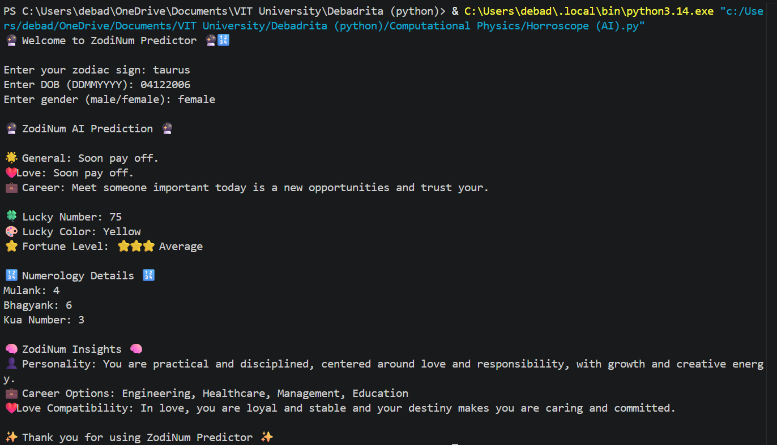

⚠️ 8. Challenges Faced
- Limited dataset for NLP generation
- Ensuring meaningful sentence generation
- Balancing simplicity with AI concepts
- Designing realistic numerology logic

📈 9. Future Scope
- Use advanced NLP models (like Transformers)
- Add a larger horoscope dataset
- Develop a web/mobile application
- Add chatbot interaction
- Improve personalization using real ML models

📚 10. Learning Outcomes
Through this project, the following concepts were learned:
- Basics of NLP and text generation
- Implementation of Markov Chain models
- Designing rule-based AI systems
- Combining multiple AI techniques in one system
- Project structuring and documentation

🏁 11. Conclusion
The ZodiNum Predictor successfully demonstrates how AI techniques can be used to build an intelligent and interactive prediction system. By combining NLP and numerology, the project provides personalized outputs while maintaining simplicity and usability.

This project highlights the practical application of AI concepts in solving real-world problems and serves as a strong foundation for more advanced AI systems.

